 | Aranmore Catholic College  Semester 1 Examination, 2011  Question/Answer Booklet

Year 10 Fundamental Science

Please place your student identification label in this box

Time allowed for this paper

Reading time before commencing work: 5 minutes
Working time for paper: 70 minutes

Materials required/recommended for this paper

To be provided by the supervisor

This Question/Answer Booklet
Data Sheet

To be provided by the candidate

Standard items: pens, pencils, eraser, correction fluid, ruler, highlighters.
Special items: non-programmable calculators satisfying the conditions set by the Curriculum Council for this course.

Important note to candidates

No other items may be taken into the examination room. It is your responsibility to ensure that you do not have any unauthorised notes or other items of a non-personal nature in the examination room. If you have any unauthorised material with you, hand it to the supervisor before reading any further.

Structure of this paper

Section | Number of questions available | Number of questions to be answered | Suggested working time  (minutes) | Marks available | Percentage of exam
Section One:  Multiple Choice | 25 | 25 | 20 | 25 | 31
Section Two:  Short Answer | 9 | 9 | 50 | 54 | 69
 |  |  |  | 81 | 100

Instructions to candidates

1. The rules for the conduct of examinations at Aranmore are detailed in the Examination
Information Handbook 2011. Sitting this examination implies that you agree to abide by
these rules.

2. Write your answers in this Question/Answer Booklet.

3. Working or reasoning should be clearly shown when calculating or estimating answers.

4. You must be careful to confine your responses to the specific questions asked and to follow
any instructions that are specific to a particular question.

5. Spare pages are included at the end of this booklet. They can be used for planning your
responses and/or as additional space if required to continue an answer.

• Planning: If you use the spare pages for planning, indicate this clearly at the top of the
page.
• Continuing an answer: If you need to use the space to continue an answer, indicate in
the original answer space where the answer is continued, i.e. give the page number.
Fill in the number of the question(s) that you are continuing to answer at the top of the
page.

SECTION A MULTIPLE CHOICE (25 marks)

Make a choice of answer and mark it with a cross on the answer provided.

1 . In pea plants, the gene for tall stems (T) is dominant over the gene for short stems (t). The phenotype
for a pea with the gene combination Tt is:

(a) tall stems.
(b) middle-size stems.
(c) short stems.
(d) TT.

2. When red flowered snapdragons are crossed with white flowered snapdragons, some of the
offspring have pink flowers, a new colour. This is an example of:

(a) cloning.
(b) incomplete dominance.
(c) mitosis.
(d) mutation.

3. In a normal body cell of a dogfish shark there are 24 chromosomes. How many chromosomes are
found in each of its reproductive cells (gametes)?

(a) 24
(b) 12
(c) 8
(d) 48

4. The part of the cell which controls cell function is called the:

(a) nucleus.
(b) cell wall.
(c) protoplasm.
(d) vacuole.

5. An organism is heterozygous (hybrid) for a characteristic if it has:

(a) two genes that are the same.
(b) more than two genes that are the same.
(c) only one gene.
(d) two different genes.

6. The units of inheritance are called:

(a) nuclei.
(b) genes.
(c) mitochondria.
(d) mitogens.

7. How many chromosomes do humans have in their normal cells?

(a) 22
(b) 23
(c) 46
(d) 44

The next two questions relate to the information below.

The following punnet square shows the likely result of breeding two hybrid black guinea pigs.
The guinea pigs black colour gene (B) dominates the brown colour gene (b).

 | B | b
B | BB | Bb
b | Bb | ?

8. The genotype of the offspring in the incomplete (?) square is:

(a) bb.
(b) Bb.
(c) BB.
(d) brown.

9 The phenotype of the offspring in the incomplete square would be:

(a) black.
(b) black and brown.
(c) black and white.
(d) brown.

10. If a sperm with an X chromosome fertilises an egg, what sex will the baby be?

(a) It is difficult to tell from the information given.
(b) It has a 50% chance of being male or female.
(c) Female.
(d) Male.

11. Mitosis results in:

(a) four identical cells with half the number of chromosomes as the parent cell.
(b) four identical cells with the same number of chromosomes as the parent cell.
(c) two identical cells with the same number of chromosomes as the parent cell.
(d) two identical cells with half the number of chromosomes as the parent cell.

12. Dogs have 28 chromosomes in their skin cells. How many chromosomes does a haploid dog cell
contain?

(a) 14
(b) 28
(c) 1
(d) 56

13. Meiosis is termed "reduction division" because:

(a) chromosomes in daughter cells are smaller in size than those in parent cells.
(b) the number of chromosomes in daughter cells is twice that in parent cells.
(c) the number of genes on a chromosome in a daughter cell is half that on a chromosome in a
parent cell.
(d) the number of chromosomes in daughter cells is half that in parent cells.
14. The actual way an animal looks is called its:

(a) genotype.
(b) phenotype.
(c) dominant type.
(d) unit character.

15. Dominant genes mask or hide the presence of _____ genes. (Select the missing word.)

(a) heterozygous
(b) pure-bred
(c) recessive
(d) homozygous

16. Where do duplicated (copied) chromosomes line up during metaphase in mitosis?

(a) Against the cell wall.
(b) Against the cell membrane.
(c) In the centre of the cell.
(d) At either end of the cell.

17. What happens at the very end of mitosis?

(a) The cell membrane splits and forms two cells.
(b) The nucleus splits again and the process continues.
(c) The chromosomes divide and move apart.
(d) Centrioles appear and release spindle fibres.

18. Three different cells contain one of each of the following sets of genes.

AA Aa aa

Which set of genes represents homozygous (pure-breeding) strains?

(a) AA
(b) Aa
(c) aa
(d) AA and aa.

19. Tongue rolling is due to the dominant gene R and the inability to roll your tongue is due to the
recessive gene r. Which of the following pairs of parents could produce a non-tongue roller
(rr)?
(Hint: You may need to do some punnet squares to work it out.)

(a) RR and RR
(b) RR and Rr
(c) RR and rr
(d) Rr and Rr

20. Major differences between males and females are determined by pairs of sex chromosomes.
For example, Jane is a girl and Jim is a boy, because in each cell nucleus:

(a) Jane has two X chromosomes, Jim has two Y chromosomes.
(b) Jane has two Y chromosomes, Jim has two X chromosomes.
(c) Jane has an X and Y chromosome, Jim has two X chromosomes.
(d) Jane has two X chromosomes, Jim has an X and Y chromosome.

21. The following pedigree shows the occurrence of colour blindness in three generations of a family.
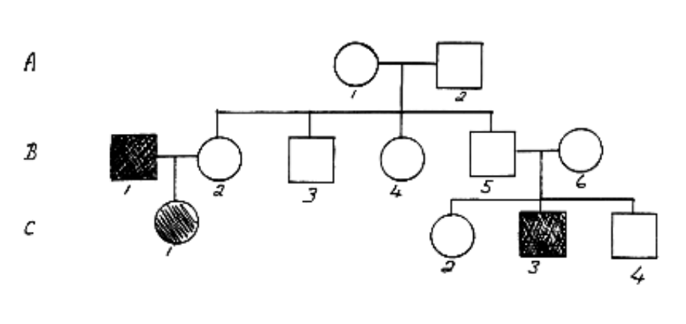

From the above family tree it can be concluded:

(a) B1 has normal vision.
(b) A2 has colour blindness.
(c) C3 is colour blind.
(d) C1 has normal vision.

22. One strand of DNA has the base sequence TTCGTCG. The opposite strand would have the base
sequence:

(a) CCTACTA.
(b) TTCGTCG.
(c) AAGCAGC.
(d) GGATGAT.

(Hint: Work out which base goes with T, C, A and G.)

23. Sexual reproduction involves two sex cells (one from each parent) which combine to produce a
fertilised cell. The sex cells are called:

(a) foetus.
(b) embryo.
(c) zygotes.
(d) gametes.

24. The process by which normal body cells undergo division is called:

(a) fission.
(b) fusion.
(c) meiosis.
(d) mitosis.

25. The genotype of a female human is:

(a) XF.
(b) YY.
(c) XY.
(d) XX.

SECTION B SHORT ANSWER (54 marks)

Attempt all questions. Write your answers in the spaces provided.

1. Complete the table below for the parts of the cell as shown in the diagram below. Choose the
correct number for the name of the part.

Part Of Cell | Correct Number
Cell membrane
Nucleus
Ribosome
Cytoplasm
Centriole
Mitochondrion
(small dot)
1
2
4
5
6
3

(6)

2. In the table below, choose the correct statement for each part of a cell. Write the letter of the correct statement next to the word.

CELL PART | CORRECT  LETTER | STATEMENT
centriole |  | A - produces food for plants.
mitochondria |  | B - controls all cell functions and contains DNA.
cell membrane |  | C - produces spindle fibres..
nucleus |  | D - produces energy for the cell
chloroplast |  | E - provides strength for plant cells.
cell wall |  | F - allows food and oxygen into a cell and wastes out.

(6)

3. In the table below, choose the correct statement for each word given. Write the letter of the correct statement next to the word.

WORD | CORRECT  LETTER | STATEMENT
dominant |  | A - how an organism looks due to its genes.
genotype |  | B - hides the other gene in a pair (e.g. T).
gamete |  | C - see a new characteristic in an organism.
phenotype |  | D - same genes in a pair (e.g. TT, tt).
pure-bred |  | E - gene that is hidden by another gene (e.g. t).
incomplete dominance |  | F - the genes for a particular characteristic.
hybrid |  | G - sex cell of an organism.
recessive |  | H - different genes in a pair (e.g. Tt)

(8)

4. Mitosis occurs in normal body cells. Answer the following questions about this process.

(a) How many chromosomes are in a normal human cell?

(b) At the end of mitosis, how many daughter cells are produced from one parent cell?

(c) How many chromosomes are found in each daughter cell?

(d) Is the answer to part (c) the haploid or diploid number?

(4)

5. In guinea pigs, rough coat (R) is dominant to smooth coat (r). Two hybrid rough coated guinea pigs
(Rr) are mated. Determine the genotype and phenotype of the possible offspring. Include percentages
to show the probabilities. Show all of your working.

Genotype:

Phenotype:

Percentages:

(5)

6. In Andalusian chickens, the black colour (BB) is incompletely dominant to the white-splashed
colour (WW). The hybrid colour is a blue-grey colour (BW).

Two hybrid blue-grey chickens (BW) are crossed. Show the possible genotype and phenotype
of their offspring.

Genotype:

Phenotype:

(4)

7. Next to each phase of mitosis, write down the name of the phase and a brief description to explain
what is occurring.
(8)
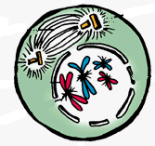
Name:

Description:

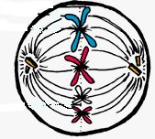
Name:

Description:

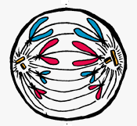

Name:

Description:

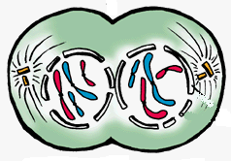

Name:

Description:

8. The pedigree below shows the occurrence of polydactyly (more fingers or toes than normal) in three
generations of a family.

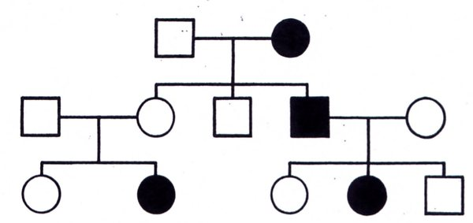

(a) Is this a dominant or a recessive trait? Explain your answer.
(Circle the part of the pedigree you are considering in your answer.)

(2)

(b) Determine the genotypes of the individuals in the pedigree. (Remember to work from
the bottom up.)

Write the genotypes neatly and clearly. If the second allele can't be determined, use a blank
space.

e.g. A_ or T_ (depending on the letter you choose).

(4)

9. Find the words listed in the following puzzle. They go vertically, horizontally and diagonally.

J | Z | C | P | U | R | E | B | R | E | D | Y | Z | G | H | G
S | Z | T | S | T | W | R | M | Y | E | U | Z | F | H | Y | E
H | S | K | Q | W | H | E | I | P | B | P | Q | A | R | B | N
E | T | A | E | V | T | Z | Y | B | D | C | R | D | W | R | O
K | W | S | X | E | V | T | N | W | O | A | U | E | S | I | T
F | U | P | M | N | O | V | S | E | E | S | D | V | W | D | Y
I | P | A | R | N | X | U | M | M | K | W | O | Q | N | N | P
T | G | J | E | E | E | Y | O | P | C | V | K | M | Q | S | E
L | M | H | L | L | C | S | W | E | D | Q | Q | T | E | D | M
Y | P | I | C | H | O | E | D | O | M | I | N | A | N | T | I
V | P | U | T | M | X | S | S | B | I | P | P | S | V | D | L
F | N | B | O | O | B | I | W | S | M | Y | O | L | Y | K | K
C | A | R | B | W | S | E | N | V | I | L | V | Q | O | A | S
J | H | C | B | Y | U | I | X | C | G | V | C | D | H | I | L
C | M | E | I | O | S | I | S | A | U | K | E | P | S | U | D
A | U | V | B | R | Z | O | M | K | H | A | P | L | O | I | D
nucleus |  |  |  | dominant |  |  |  | recessive |  |  |  | hybrid
gamete |  |  |  | chromosome |  |  |  | genotype |  |  |  | phenotype
purebred |  |  |  | ribosome |  |  |  | diploid |  |  |  | meiosis
haploid |  |  |  | mitosis

(7)

END OF EXAMINATION

